1. Please follow these instructions on how to download and install the Arduino Software onto your computer. You will need the USB A-B cable that was shipped with the Buddha device.
   1. <https://www.arduino.cc/en/Guide/HomePage>
   2. Click either Windows or Mac OSX to get more detailed step by step information
      1. Make sure to choose the correct board (Arduino Uno).
      2. Choose the correct Serial Port. Instructions say to use /**dev/tty.usbmodem** (for the Uno or Mega 2560) but my device connects with **/dev/cu.usbmodem**. Try both to see what works for you.
      3. 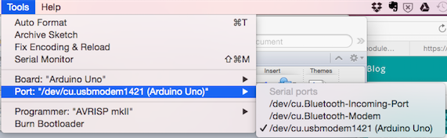
2. Download the attached zipped folder anywhere on your computer.
   1. There should be 3 files:
      1. 
3. Double click on the '_2015_07_08_buddha.ino' file and the Arduino program will launch
   1. 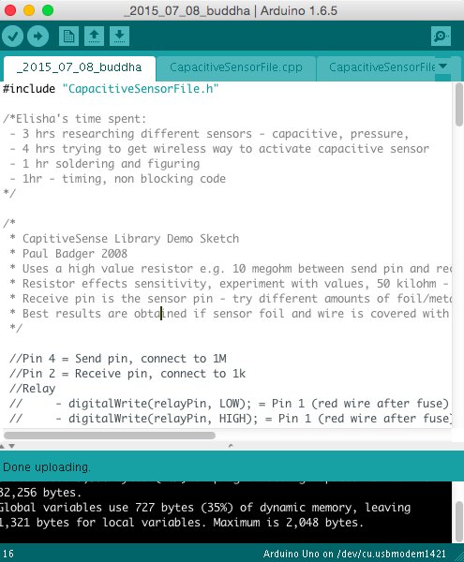
   2. You will see 3 tabs of files
4. Click the top left checkmark 'Verify' button 
   1. If this works, then you have downloaded all the necessary files and the program is correct
   2. At the bottom of the IDE, it should say ‘Done compiling’
   3. 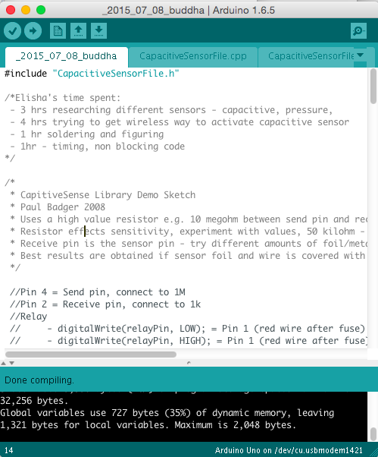
5. Click the arrow 'Upload' button 
6. If uploaded well, it should say “Done uploading”
   1. 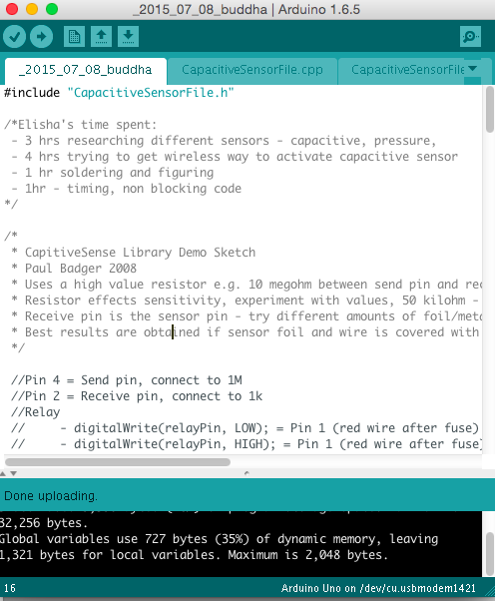
7. Common troubleshooting errors
   1. If there are errors, try reconnecting the USB cable to the computer or connect the cable to a different USB port.
      1. On the Macbook Pro and Macbook Air, the USB port on the left side of the computer (next to the power connector port) usually works the most consistently
   2. You can also try changing the Serial Port under Tools/Serial Port.
   3. You can also try connecting and reconnecting the USB cable from the computer
   4. You can also try restarting the Arduino program
8. Once uploaded, the Arduino will immediately run the program and you can test the device as you did previously. You can also change the USB A-B cable back to the 12VDC Power adapter, 1A cable and run the Arduino as you did previously.